FINANCIAL SUPLICATION

Acquaintance and Presentation
Who are we?
Members of SDA Church Vratsa, Bulgaria are writing to you. Our church has been established in 1946 by one of the very first Bulgarian pastors – Boris Ortov. During the communist regime (1946 – 1989) the church has been growing slowly but steadily. Until 1992 it had approximately 20 members who had been gathering in private homes. Pastor Harald Knott from Switzerland was the first to conduct evangelistic series in our town at 1993 and consequently the church membership doubled. Simultaneously the church building was purchased.
As a result of its outreach program, the SDA Church in Vratsa currently has 113 members.
Your visits and contacts with us will encourage and enrich us.

Problem and Need
What is our urgent need?
The sanctuary in the church building consists of two rooms with a total area of 40 sq.m. It seats maximum 75 people. Due to the growth of the membership and the continual increase of visitors and contacts (approximately 130 people) we desperately need to enlarge the premises.
We need $55 000 (EURO 45 000) for the reconstruction of the building to better suit the needs of the congregation.

Resources and Fund
What have we accumulated so far?
Thanks to the sacrificial willingness of our brethren and sisters from Switzerland, so far we have accumulated CHF 13 000 – approximately $10 500. We need $44 000 (EURO 36 000) more.

Potential and Possibilities
Why do we need your help?
Due to the economical crisis our country is experiencing, it is practically impossible for us to accumulate the whole amount of money by ourselves. As a result of the low income of the average Bulgarian and among the church members ($80 per month average), the possibilities of our members are really limited. Nevertheless, the believers are doing their best and every church member allots money for this purpose, according to their means.

Design and Project
What will be done with your funds?
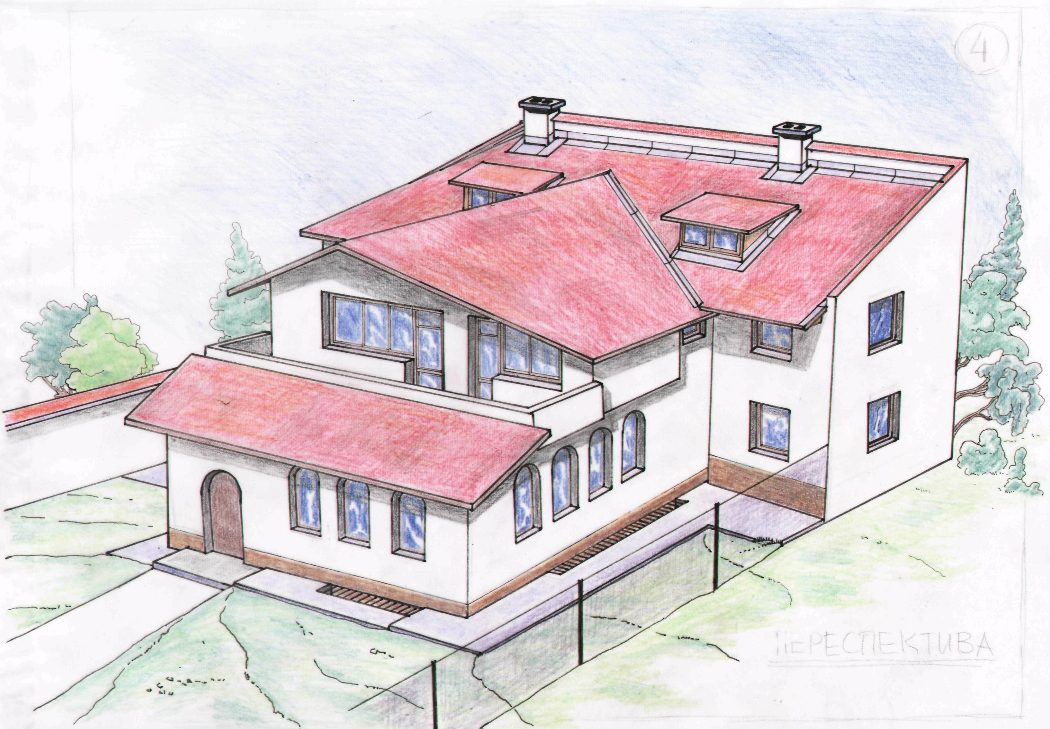
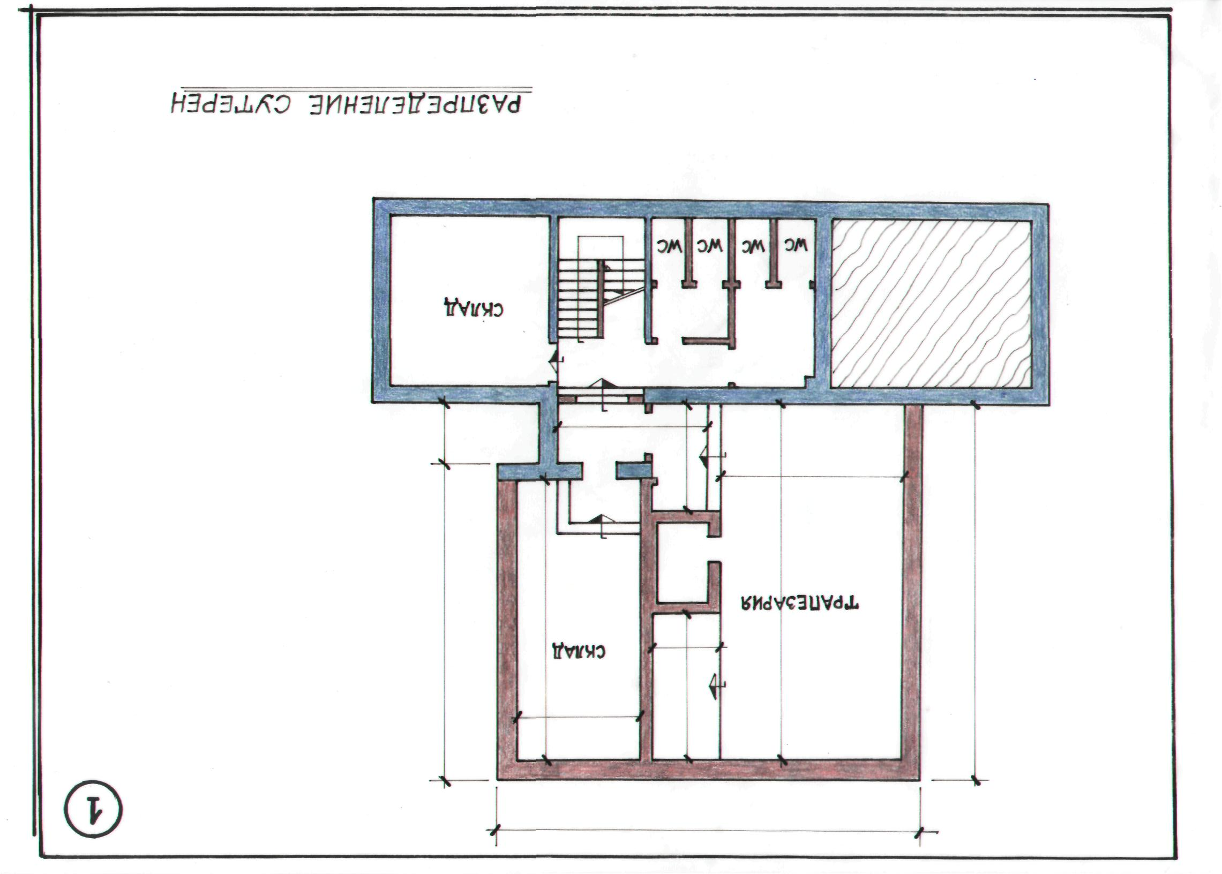
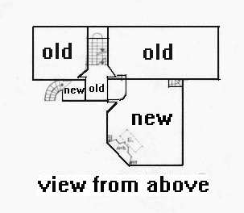

NEW
OLD
View from above

The project provides for the enlarging with 90 square meters of the place of worship. This means 80-100 seats more.

Assistance and Help
How can you help?
- You can share our supplication with friends and people who can help.
- You can tell us about someone who can assist.
- You can send us funds according to your possibilities.
If you call us to confirm your donation we shall inform you about everyone who had helped us to that moment and you also will be included in the honorable list of contributors for Vratsa SDA church.

Supplication and Will
What is our motivation?
Maybe this is not the first letter with that request, and we want apologize you, if it is an unpleasant for you!
Our strong desire is that by that project Vratsa SDA church may become a delightful place for every visitor. We hope and believe that everything will be done according to God’s plan.

You can find more information on the following addresses and telephone numbers:

General Conference
Euro-Africa Division
http://www.euroafrica.org/admin/directory/union.html
BULGARIAN UNION OF CHURCHES
(Bulgarian Union of Seventh-day Adventist Churches)
Solunska 10, BG-1000 Sofia
Telephone number of the Bulgarian union of SDA churches:
+359 2 989 22 77
Fax: +359 2 980 17 09
N. Levterov, President
E-mail of the president of the Bulgarian union of SDA churches Pastor Nikola Levterov:
levterov@techno-link.com
T. Mitev, Secretary
S. Vlasakev, Treasurer
E-mail of Bulgarian union of SDA churches:
sda.bg@tradel.net
office@sdabg.org
E-mail of the Pastor of Vratsa SDA church Trifon Trifonov:
trifon_str@abv.bg
Telephone number of Vratsa SDA church:
+359 92 621 146
Visit our web-site:
www.vratsa.sdabg.net

